# Brief

This assessment activity requires you to create a multi-page website that may be included in the Moodle e-learning resources (or similar) for Year 11 Digital Technologies students. The purpose of this website will be to teach students about an aspect of Digital Technologies and to demonstrate an advanced media technique in use. You are required to develop and incorporate an advanced media technique (such as JQuery or JavaScript) for this purpose.

I intend to develop a website that teaches Year 11 students some year 12 concepts as well as provide some advanced tips and tricks.

# Specifications

The website should:

* Be at least three pages (negotiable with teacher)
* Use advanced media techniques such as JQuery
* Teach an aspect of digital technologies to a year 11 Onslow College student
* Be well-designed and appealing to the target users
* Have well-commented and valid code
* Have well-organised information and be easy to navigate
* *...any other specifications you would include?*

# Target Audience: Year 11 Students

# Stakeholders:

These are the people, groups or organisations that are important in either the problem or the solution. Most will benefit in some way from the solution.

* Year 11 Digital Students (Past, Present and Future)
  + They will be the primary consumer of our website. Past Year 11 students can feedback on how effective the solution will be.
* Digital Teachers
* Onslow College
* NZQA

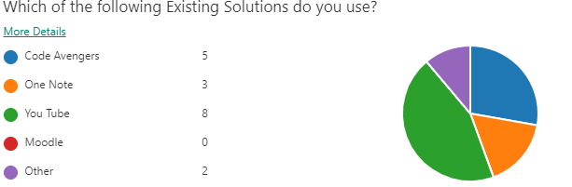

1) I asked year 12 students what existing solution they liked. A majority indicated that they strongly prefer YouTube over other solutions.

This is most likely because

 I then asked people what they liked about their existing solution. The top answers here were “contains a lot of info” and “Easy to follow (Step by step)”.

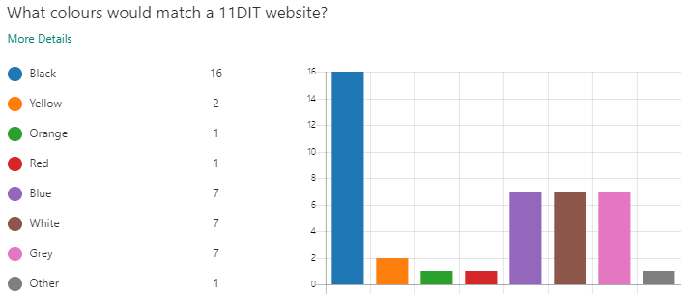

2) Here I asked users what colors would match a 11DIT website.  A majority of users indicated that they liked Black as a main color, while white, grey and blue were all tied at second.

This information suggests that I should design a website that features blacks prominently. However, I don’t think that designing exclusively around black is a good idea. The feedback also suggests that using blues as another design color wouldn’t be a bad choice. I think that grey and white would be better as accents rather than colors I design around. So in my final color choice, I should aim to produce a color scheme that features blues, with some touches of blacks, as well as whites and greys if necessary.

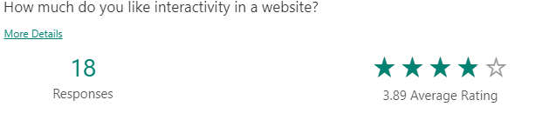

3) Here i asked users how much interactivity they enjoy in a website. The average rating was 3.89, with all answering either 3, 4 or 5.

The information suggests that interactivity in a website is good to have, but not everything needs to be interact-able.

4) I asked users what they enjoyed most in a website. A majority indicated that they preferred minimalism, or as simple as a design as possible.

This correlates with the current trend of minimalism in web design in 2019. This is a popular design style because the less elements and information present on a website, the less the user will have to think. I will design my website with this idea in mind, and try not to clutter my screen.

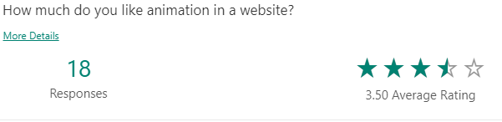

5) Users indicated that they enjoyed some animation on a website, but not too flashy. Based on this information I will refrain from animating my entire website.

Considering previous answers indicating they liked no clutter, and the same amount of interactivity, it seems that the feedback is consistent in that animation shouldn’t be over the top.

# Relevant Implications

Aesthetic aesthetics are something I need to consider when I design my website. According to the interactive design foundation, “Aesthetics is the philosophical study of beauty and taste. …In the field of user experience (UX) design and interaction design, aesthetics is important because it impacts the UX of a product in several ways.”

I need to consider this because if my aesthetics are too intrusive and distracting, they will affect my user experience negatively. I believe that aesthetics should only add, never detract. To make sure my choices aren’t negative, I’ll use different simulators to check that my website functions to people of different specifications, such as colorblindness. I can also get feedback to see whether others think my website is too distracting.

Intellectual Property is another implication I need to consider. The definition of intellectual property according to google is “intangible property that is the result of creativity, such as patents, copyrights, etc.” In other words, it is the work of others that they have thought up/created, and is protected by law.

I need to consider this because if I end up using work that is not mine in my website without getting permission, it’s a massive breach of etiquette and goes against the law. To make sure that I’m not stealing other’s content knowingly/unknowingly, I’ll source any images that I use, if any, from Wikimedia commons. Wikimedia commons is a site that

# Analysis of existing solutions:

Websites:

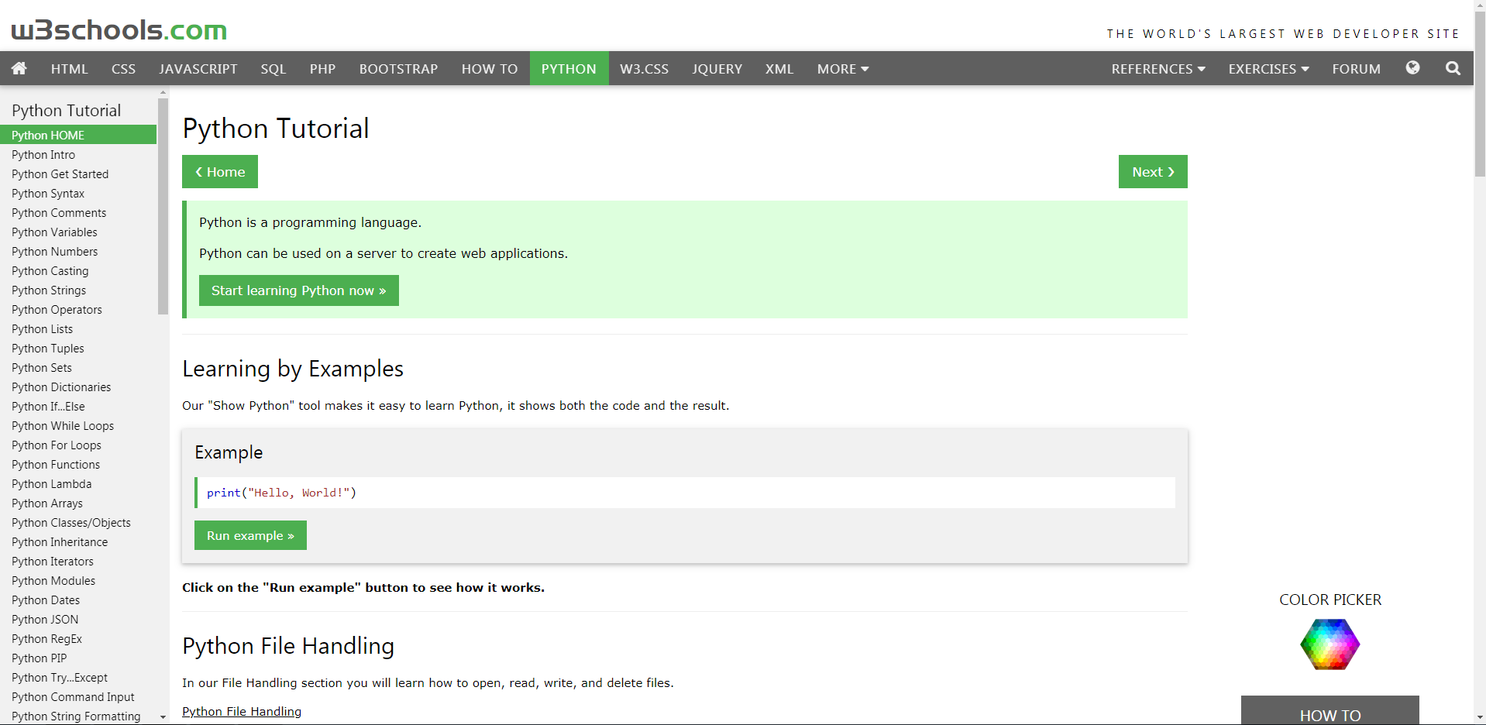

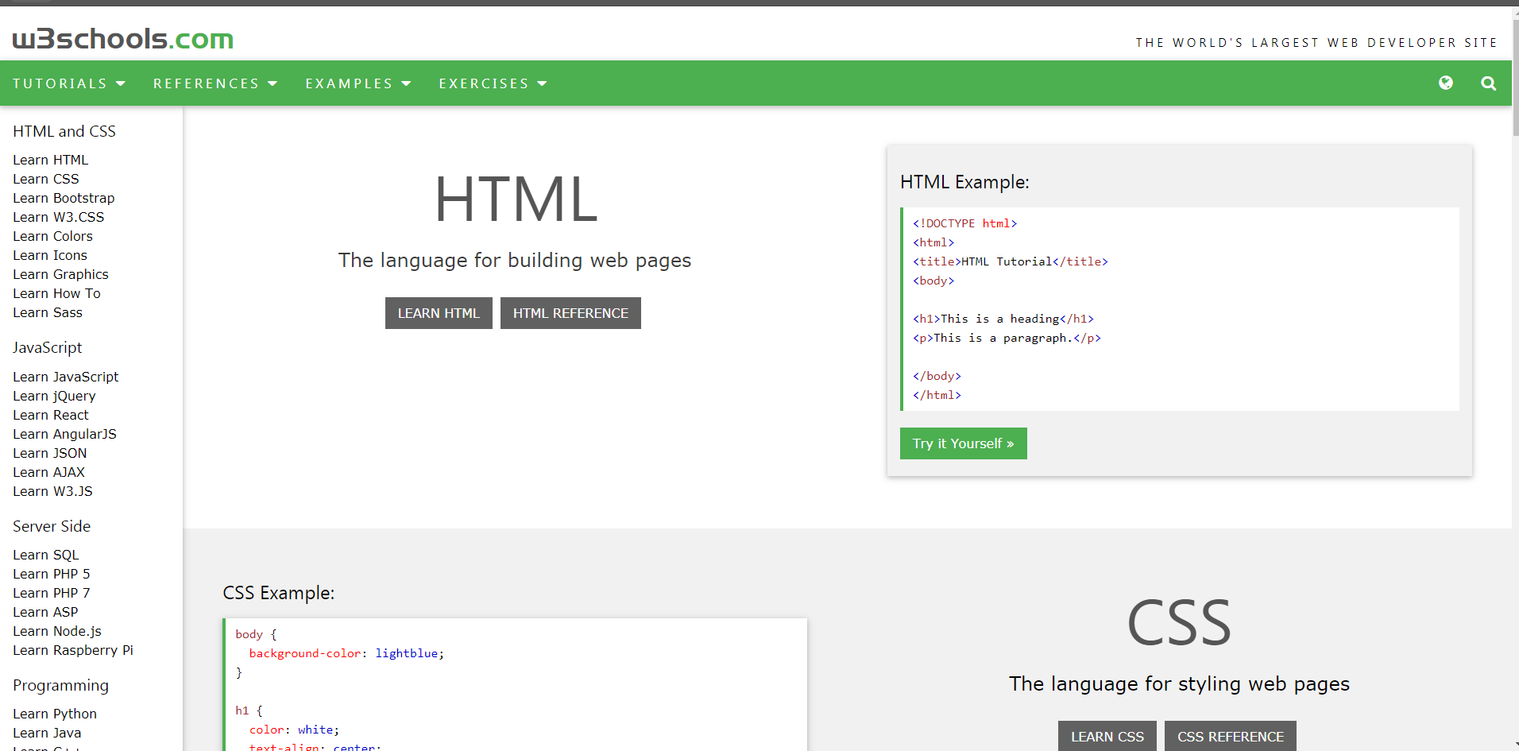

[www.w3schools.com](http://www.w3schools.com)

This website is highly reputed for providing valuable coding help for a wide range of languages, and I’m sure a majority of students can recognise the name of this site.

|  |  |
| --- | --- |
| Positive (Interesting)   * This website uses a very basic color scheme, using only whites and greens. This simple color scheme means that users aren’t distracted by flashy animations and cool web graphics and can focus fully on finding code. * This website doesn’t actually utilize any animations, at least from what I’ve seen. Their transitions are all instant. This could make it easier to run on the lower end, but also ensures that it’s robust and that it will work for a wide range of websites. * This website has no sticky elements. | Negative (Interesting)   * I think that having a about on the home page would be nice so that the user isn’t immediately overwhelmed with all the cool stuff they are able to learn. * Something that I think is interesting is that the nav bar is different when the user actually selects a topic to learn, and the nav bar to the side changes to similar topics. * Even though there’s a dark theme toggle on their code editors, there isn’t one on the main sites. This could be because they wanted to keep the website lightweight. |

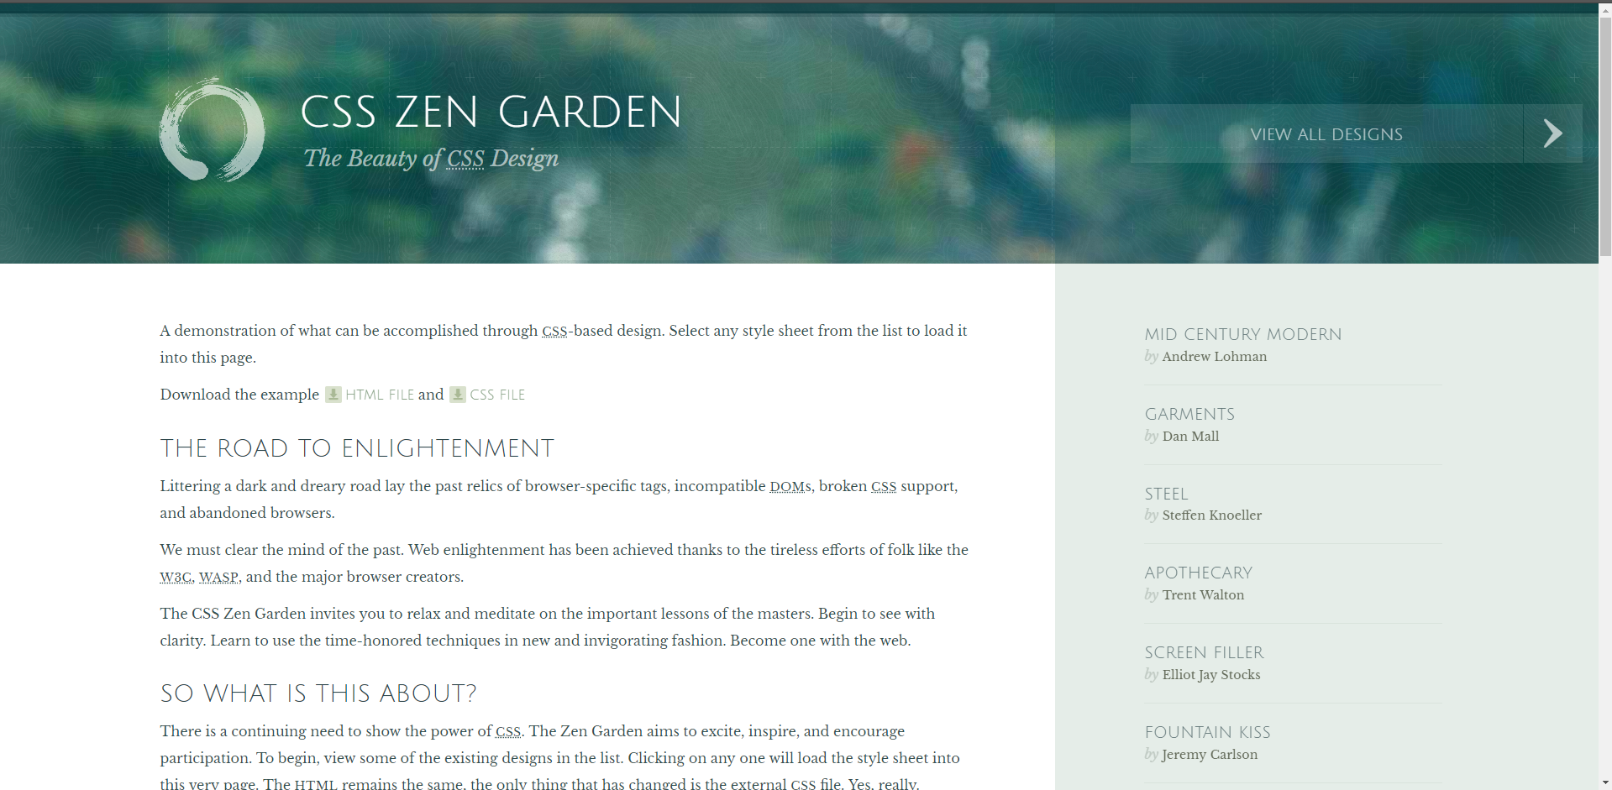 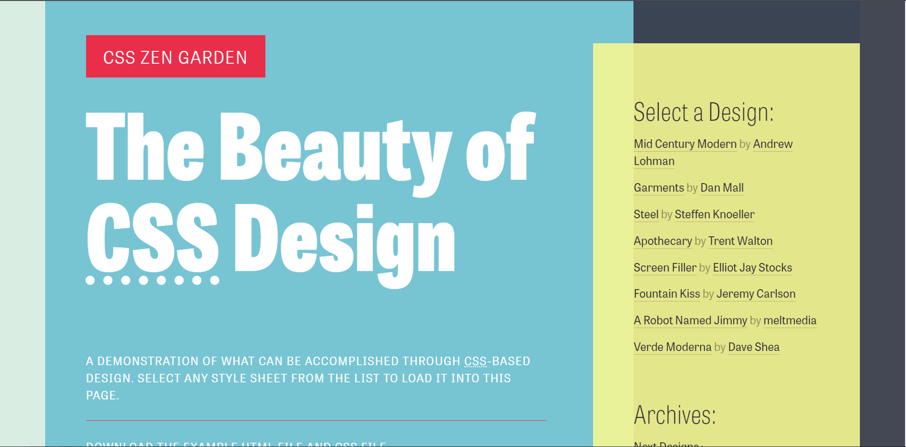 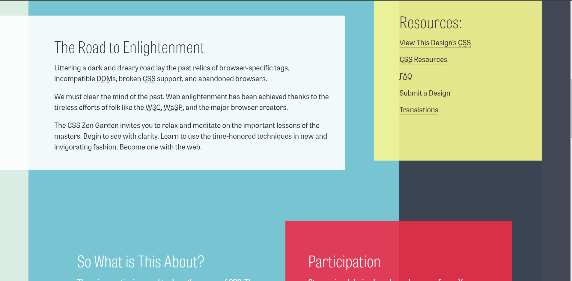<http://www.csszengarden.com/217/>

<http://www.csszengarden.com/>

CSS Zen Garden is a website that most web designers are familiar with, as it provides a wide plethora of CSS designs that use the HTML, which shows just how important CSS is to a website.

The index of this website leads you a nice

|  |  |
| --- | --- |
| Positive (Interesting)   * The index of this website has a nice layout. | Negative (Interesting) |

# Design ideas

## Python is a object-oriented language.

Python - Object Oriented. Python has been an object-oriented language since it existed. Because of this, creating and using classes and objects are downright easy. This chapter helps you become an expert in using Python's object-oriented programming support.

## Fonts

What kind of fonts are there for a website? There’s many different types of fonts that are used for different purposes. Here, I’ll do an evaluation of each type of font.

**Serif:** Serifs are actually what the little lines at the end of characters are called. They’ve been in use for a long long time, and originate from the time period of Ancient Rome, from the characters that were chiselled into hard marble.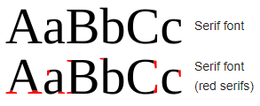

As we can see from this image, Serif fonts are fonts that utilize a little line at the end of characters. These fonts are often used to exude a feeling of elegance and class. There are 4 subclasses of serif fonts that mainly differ with line width. Old style serif (also called humanist), transitional serifs, modern serifs and slab serifs. Old Style serifs feature thin lines at diagonal/angles places. Modern Serifs have a lot of contrast between their thin and thick lines, and have a very vertical feel. Transitional serifs use a variety of line widths like modern serifs, but much less contrastingly. Slab serifs have near to none variety in their line width.

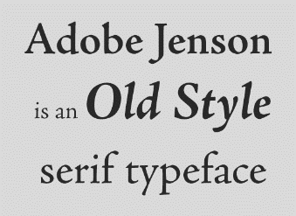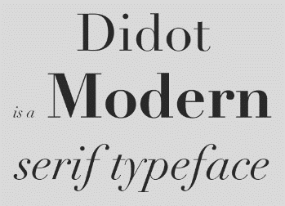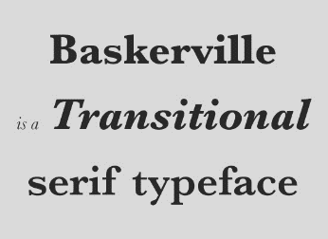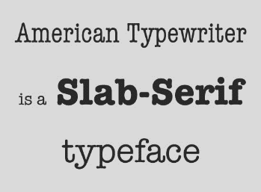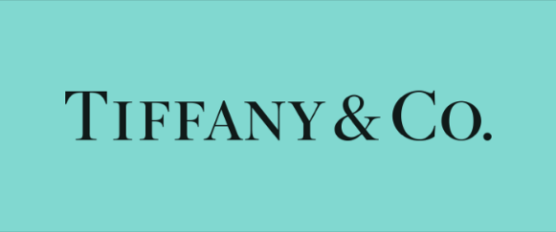

Tiffany & Co is a company that sells high end jewelry, and can be considered a prestigious and high-class company. Their logo uses a serif typeface. This is effective because serif fonts are considered formal, which is exactly the feel a company like Tiffany & Co want to give off. In this case, the font gives off a feeling of prestige. Modern Serif

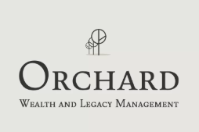

Orchard, as you can tell from the logo, is a Wealth and Legacy Management company. They also tend to deal with people that are wealthy and prestigious. In order to attract those kinds of people, they have also utilized a serif typeface as their font of choice. The formality of the serif style is perfect because in this case it gives off a feeling of traditionalism, which in turn produces trust.

Sans-serif: As the name implies, Sans-serif fonts are fonts that do not have serifs. These fonts convey an opposite feeling to the serifs, namely that of playfulness and a casual tone. They also look more modern in contrast to the traditional feel of serifs, hence their increased use in companies that try to project a more modern and innovative feel. There are 4 different classifications of sans-serif typefaces, namely:

* Grotesque
* Neo-Grotesque
* Humanist
* Geometric

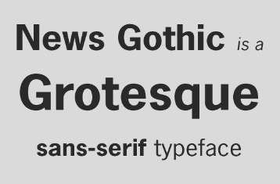Grotesque typefaces are the earliest iterations of sans-serif fonts, and are serif like in nature, just without the serifs. Neo Grotesques are more common, and some of the most well-known fonts are neo-grotesques. Examples include Helvetica, Arial, MS Sans serif and many more. Humanist type-faces are, as the name suggests, are more calligraphical in nature than other sans-serifs. Since they utilize a variety of line widths they are also more legible to the average user. Because of these traits, they tend to be used a lot in websites.Geometric type faces are based on geometric shapes. This means that curves tend to be based on a complete circle, a notable example being the ‘o’s. Lowercase ‘a’s tend to just be a circle with a line. These typefaces aren’t as suitable for body, instead being suited to headers and such. This typeface is the most modern of the bunch, and you can see it being used in big name tech companies such as google.

<https://www.jotform.com/blog/a-crash-course-in-typography-the-basics-of-type/>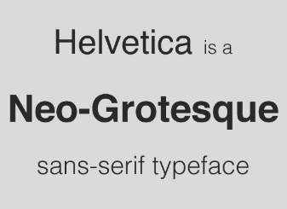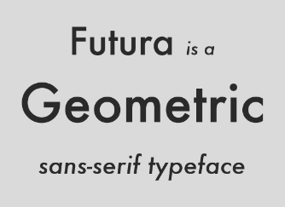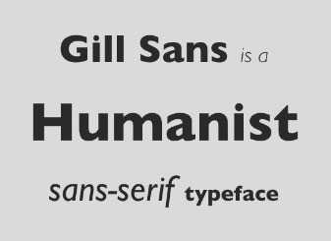

The

Handwritten – Anything that mimics handwriting is considered a handwritten font. Cursive fonts, for example, are often used in formal invitations.

Decorative – These are informal fonts that are entirely original. These fonts are interpreted as quirky, creative and fun.

### Headers

#### Archivo

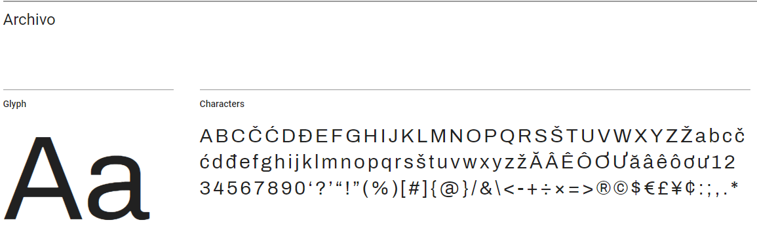 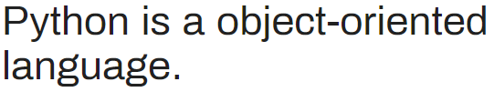

#### Titillium Web

This font has a very technological feel, with a very rigid structure that avoids curves as much as possible.

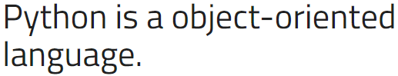

I think that this font is an excellent choice for a header font, as its very attention grabbing yet minimalist.

#### Varela

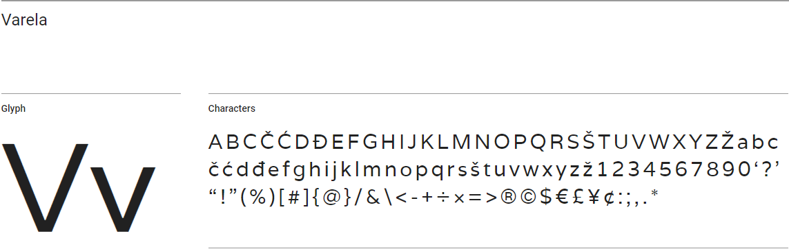 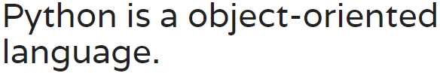

### Body

#### Open Sans

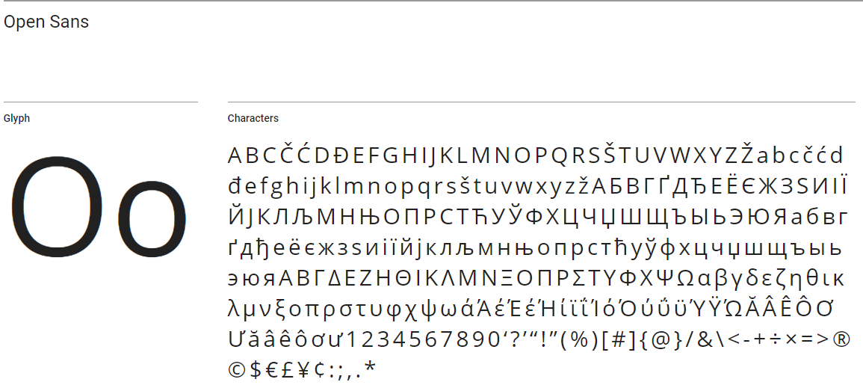 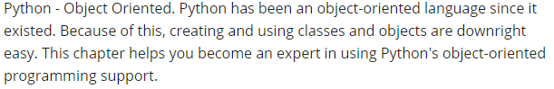

#### Roboto

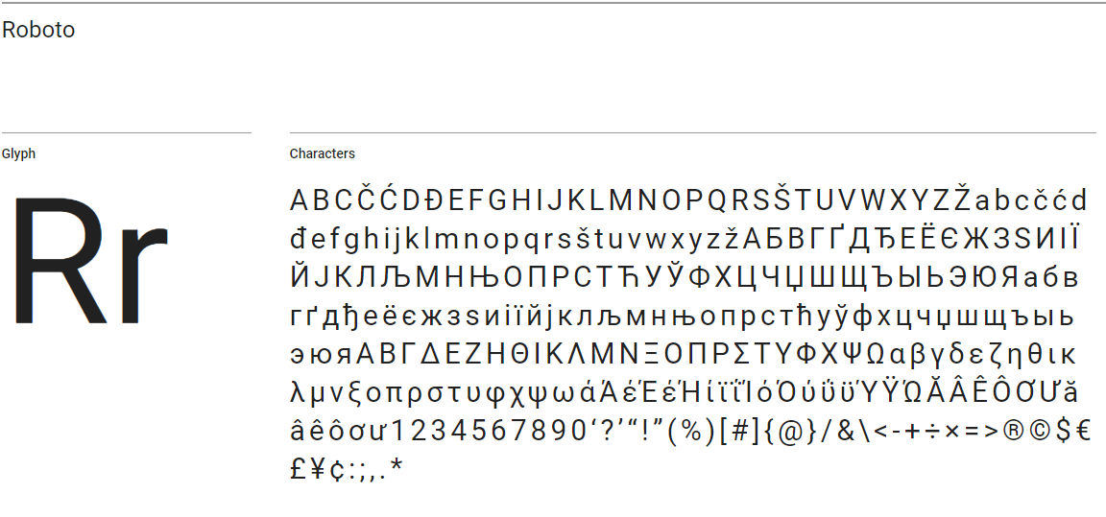 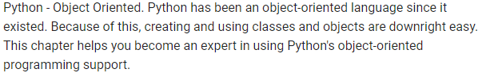

#### Muli

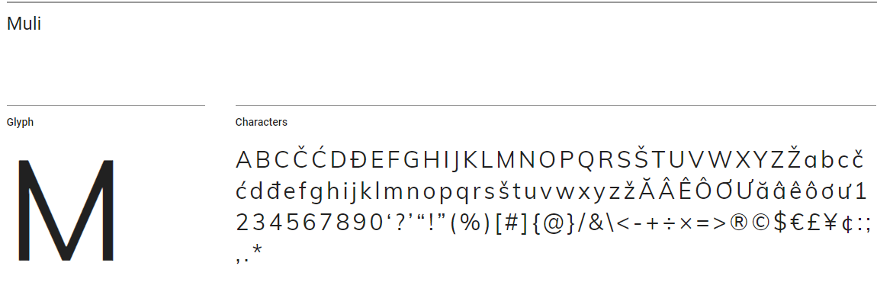

Muli is a sans-serif font that is excellent for body text

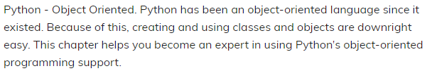

### Refinement

My stakeholders have suggested that they prefer Titilium web as a header, so I’ll be using that in all my schemes.

#### Titilium Web

Header: 700, 900, normal

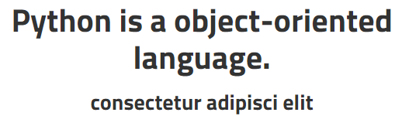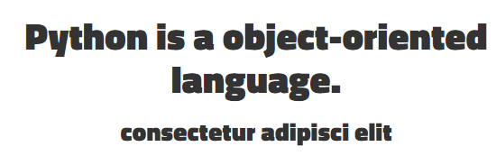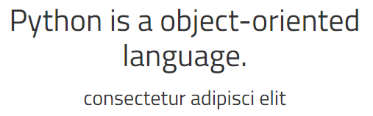

Body:

Open Sans: Normal, 600, 300

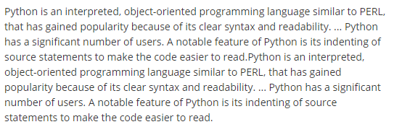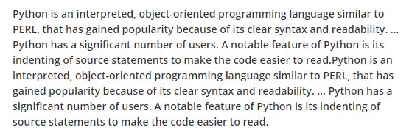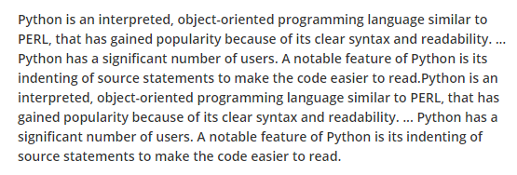

Roboto: Normal 500 300

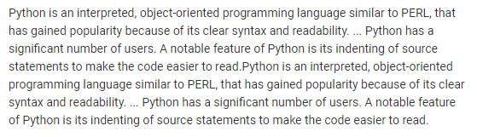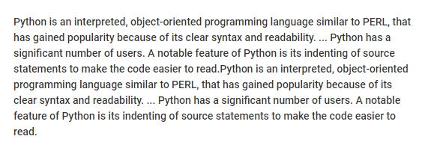

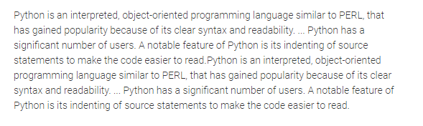

### Further Refinement

Titilium Web 700, Open sans

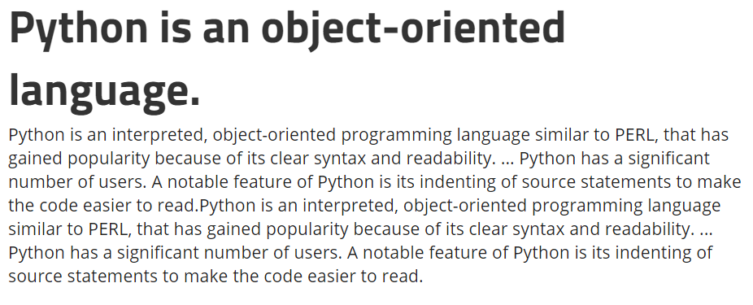

Titilium Web 700, Roboto

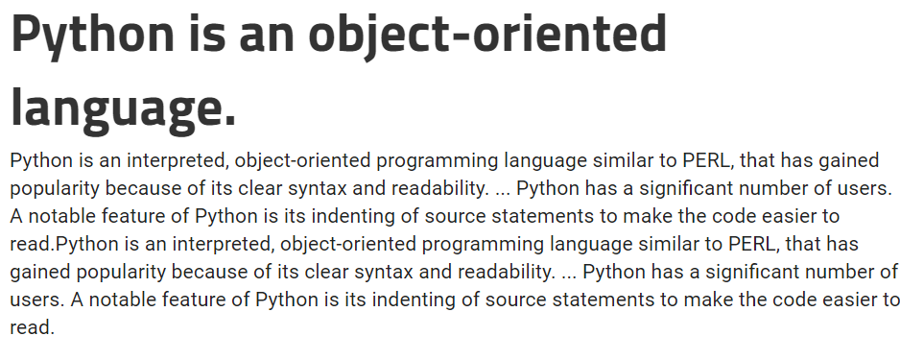

## Color

Based on the feedback from stakeholders I received initially, it seems that they prefer blue, black and white colors. I’ve gathered some different shades of blue black and white, as well as some variations like green and purple.

1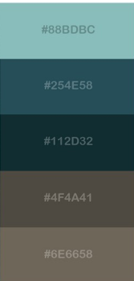2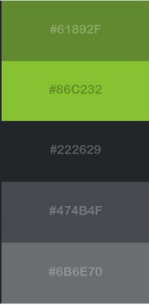3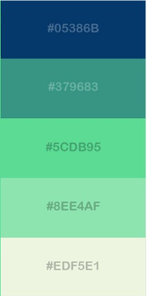4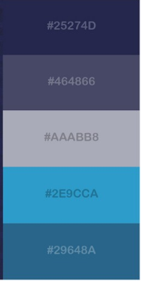

5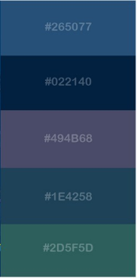6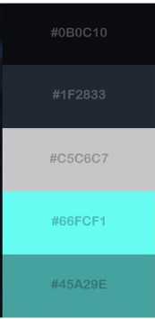 7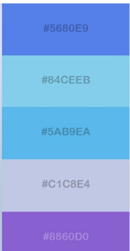

I want a darker tone for my website, as I feel that bright colors would be quite distracting. Especially since I know that digital students tend to work at night, dark colors would be better functionality-wise. Out of these colors, 7 is way too bright in my opinion.

After consulting with my stakeholders, I’ve come to the conclusion that they prefer color scheme 2 the most. It seems that they are consistent with their initial feedback in which they indicated that they preferred blue and black. All the

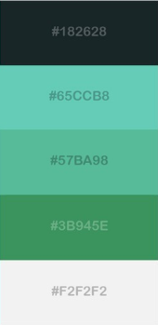1)2)3)

These 3 color choices are the ones that make it to the next stage. In this selection, we feature a lot of greens and blues which is definitely fitting for a digital website. It seems that my stakeholders preferred brighter shades of blue, which is interesting. Overall, this correlates with the data I received from my stakeholders at the start of the project.

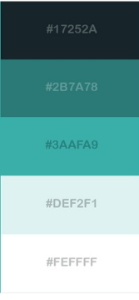At this current stage, I’m still not quite sure what color scheme I want to run with. So I consult more stakeholders.

 Here are some refinements of color scheme 2. It turns out users liked some green, so I included some more green into the second color scheme. I had some feedback that color scheme 6 was too bright, so I darkened the blues while added some brighter whites.

Will Wood)

My favourite colour schemes are number 2 and number 5. I like number 2 because the two dark tones work well with the bright shades of blue and I think you could use the two bright colours well as an accent colour on your website and it is bright enough to be recognised by those with colour-blindness (u can use that for relevant implications hehe). Though, I don’t like that it doesn’t have a strong highlight colour such as a white to balance out the dark shades.

Secondly, I like colour scheme number 5 because the green and the blue work well together, and you could use the two colours to bounce off each other in your website design. Though, I think the shades may be too similar and will blend in, which may not be what you wanted to do.

row oglv

My preference is the fifth colour scheme, as it is less of a gradient and has a more stable balance of highlights and solid colours like white and black for text and background, with the more vibrant colours better for accents or buttons. I also like the one next to it because there is a highlight colour that is slightly tinted blue that could be used with white or blue as a highlight.

Mr Fairhall

I prefer number 3 over 1 and 2, however I quite like the last 2 over the the first three. The reason is that the ones before are quite dark, but the lightness of the last 2 is really nice, but I can’t decide between them

Declan

My favourite colour schemes are the fourth and the fifth. If I had to choose one, I would probably go with the second since it has lighter colours and I like blue better but I think if there are big dark parts in the page then you should try using a more dark grey rather than the bluish #17252a. Blue also feels more modern and has a digital feel to it. What you could also do is have a colour scheme using blue and green together that can be used in a gradient.

Based on feedback I’ve chosen the fifth one.



## Wireframes

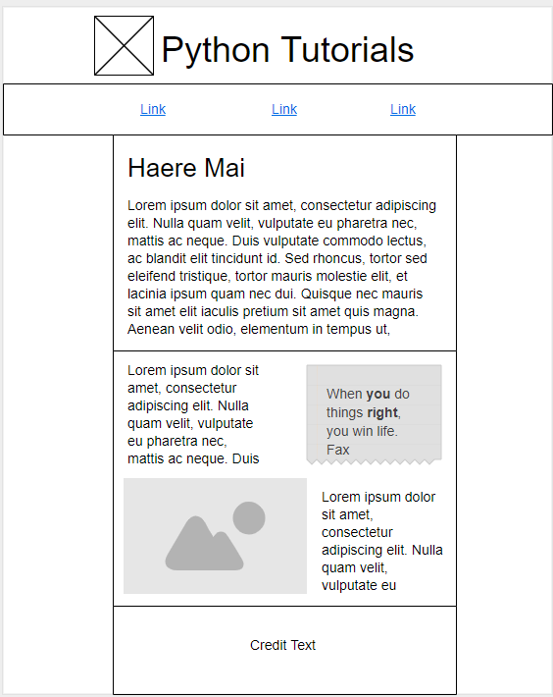

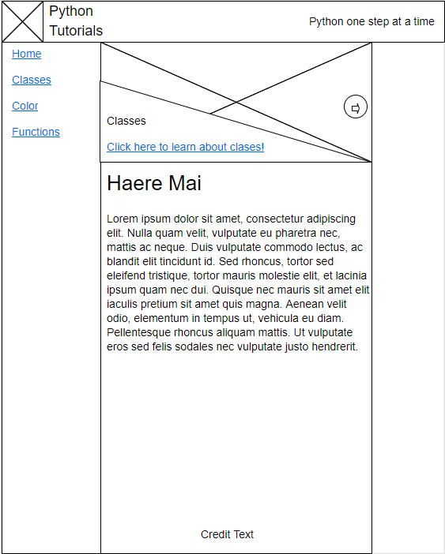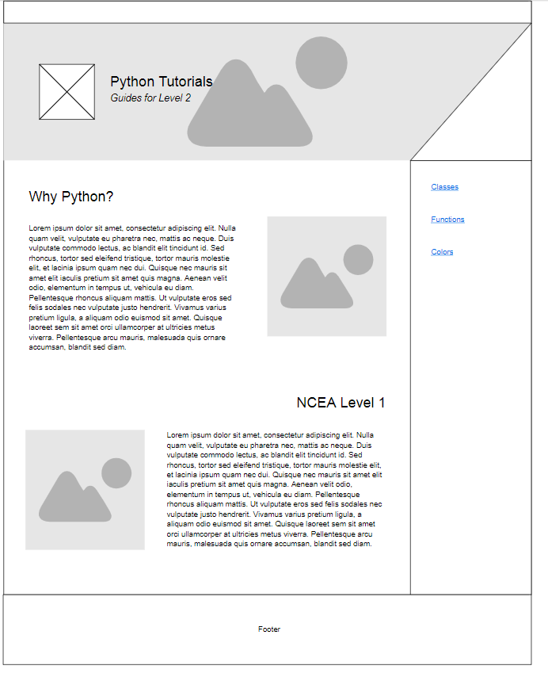

## Wireframes + Color

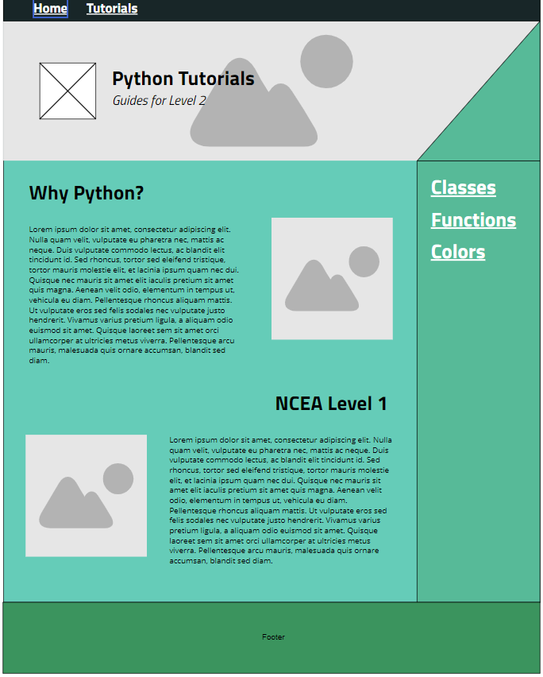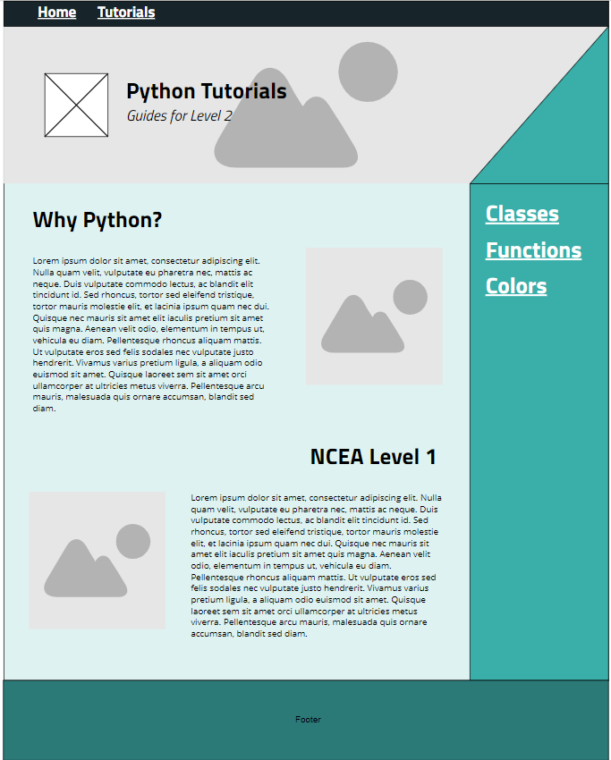

Based on the feedback, I’m using color scheme 2

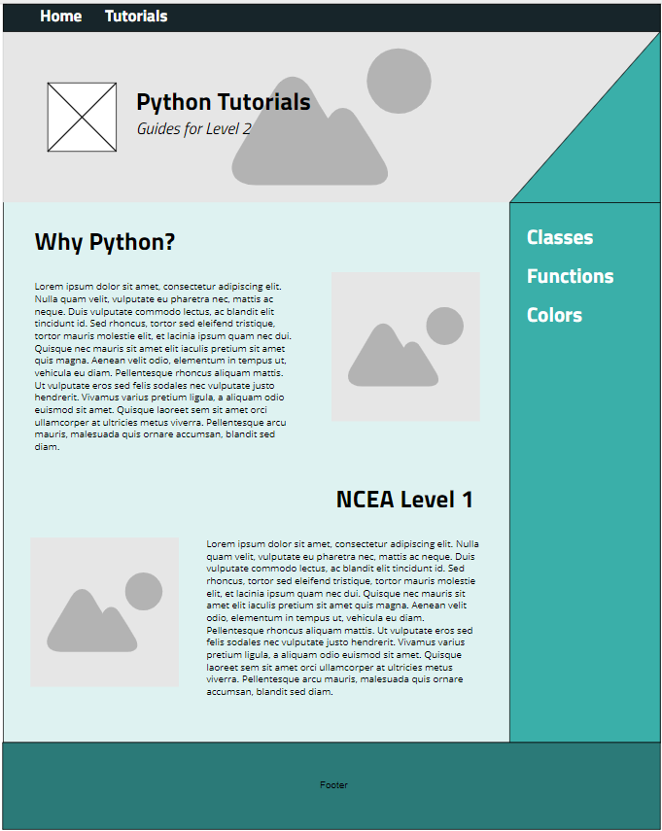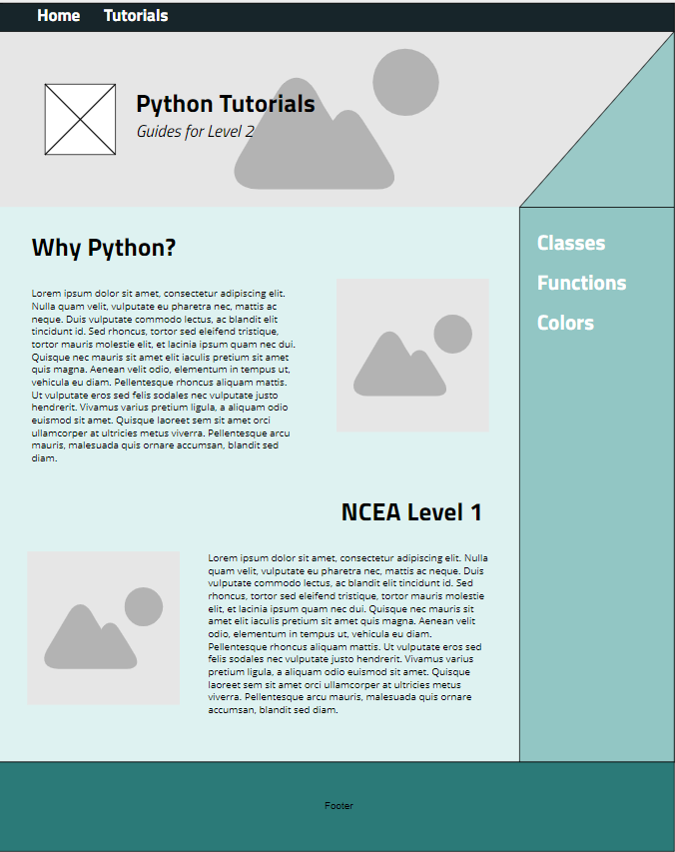

Final

